Review: The CZ P10 S Pistol
Tom Marshall
Join the Conversation
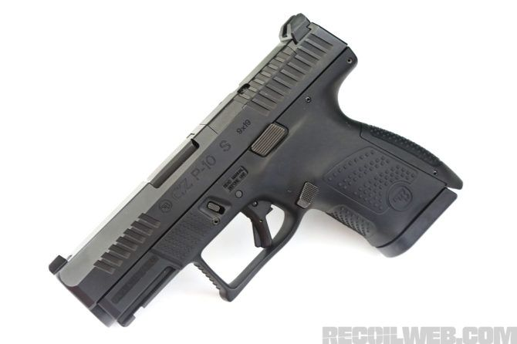
This article originally appeared in CONCEALMENT Issue 13

CZECH YOURSELF…
The CZ P10 S Puts Full-Sized Features in a Palm-Sized Package
Way back in CONCEALMENT Issue 7 we had the chance to review the then-new CZ P10C. Since then, the market for black striker-fired auto pistols has only gotten larger and more densely packed. But the P10 C continues to stand out for its superior set of out-of-the-box features and its above-average ergonomics. From its inception, the P10 C was meant to be the first in a family of striker guns. While it’s taken a little while to get that enterprise off the ground, CZ USA has finally delivered the “gen 2” of the P10 C, as well as it’s bigger and smaller siblings — a full-sized P10 F and the subject of this article, the subcompact P10 S.

The Same, But Different
While the original P10 C came to us direct from the Czech Republic, new-manufacture P10 pistols, including the diminutive S model, are produced at CZ-USA’s Kansas City facility. This change in provenance includes some additional upgrades for the end user. Namely improved grip texture, improved trigger, and some increased parts commonality between the three models. We also noticed that barrel lock-up was better and there was some differences with the recoil system. While none of the changes were particularly earth-shattering, we’re glad to see that this series is continuing to improve and evolve.

1/6
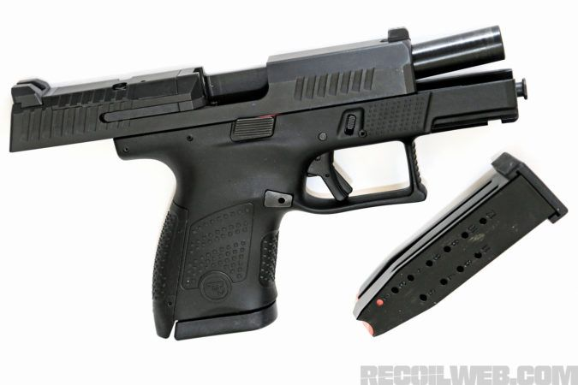
P10 S mags put 12 rounds on tap, giving it an endurance factor beyond many of its same-size competitors.
We were dually impressed with the original P10C trigger — in fact, we’d say it’s one of the best out-of-the-box striker triggers out there right now, particularly at a price point that’s competitive with anything else in its class. But our test sample of the newer P10 S seems to sport a trigger that’s been further cleaned up. The bang switch on our test gun had about a ½ inch of clean slack before hitting a hard wall which broke at an average of just under 5 pounds on our digital gauge. The reset is aggressive and positive with a ¼ inch of travel. There was minimal stacking and zero over-travel. While we’re perfectly content with the stock trigger (a rarity for this author) there is an aftermarket option from HB Industries that will fit new-manufacture guns.

2/6
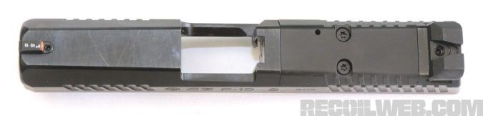
Now, among new models, the different size mags can be interchanged. But if you own an original P10 C, you might have to spend some coin on new gas tanks if you make the jump to a new-manufacture pistol. On an interesting side note, if you own a P07 or P09 pistol, HB Industries can modify those mags to run in a P10.

Rounds Downrange
We spent a few weeks playing with our P10 S and ran a handful of different rounds through it from 115-grain Magtech target loads to Federal HST Micro 150-grain slugs and had no issues whatsoever.
The factory iron sights are metal, configured with a serrated, plain black rear and a tritium front. The rear notch is nice and wide, making snap sight pictures a cinch. But this is far from a belly gun. We were able to hit 6-inch steel out to 20 yards with a gun almost small enough to palm — a testament to the aforementioned iron-clad lockup.
We handed this gun off to several regular range buddies who were all able to repeat similar results, keeping rounds in the A-box at distances well beyond what most people will see with a pistol of this size. Since the P10 S is available in an optics-ready configuration, we’re sure that the distances could be pushed even further with a dialed-in red dot and a little practice. Speaking of bolt-on’s the P10 S does come with an accessory rail molded into the frame. We had two standard-sized weapon lights on hand, a SureFire X300U and a Streamlight TLR-1. Neither one would fit the shorter dust cover, but we imagine a small light sized for sub pistols would have better success. Holsters from Dara Holsters and JM Custom Kydex that were built for the larger C model both accepted the subcompact without any issue. Mag pouches are a slightly different story. The magazines fit, but sit nearly flush in the pouches we had. As always, make sure that any accessories you have are meant to fit the gun you’re running.

3/6
nb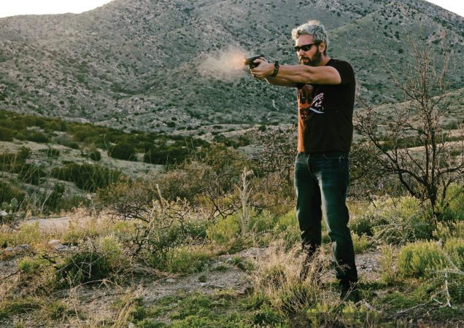
The P10 S, while not as soft-shooting as its larger siblings, lacked the jarring muzzle flip of other guns in this weight class.
The two biggest gripes we have (and hear) about shooting subcompact guns kind of go hand in hand, no pun intended. One is recoil management, the other is the ability to get a solid grip on the gun. The former is a matter of physics. Shooting the same bullet out of a smaller gun simply produces more felt recoil. This leads to a general trend of smaller guns being “snappier” or “jumpier” in the hand. There are only a few ways to mitigate this, one being the ability to secure a full two-handed grip on the gun. For the author, the P10 S, even with flush-fit mags, is just long enough to get a full grip on. Your mileage may vary, but basepads are out there and inexpensive if you have tennis racket hands and need a little extra real estate. Overall, we felt that the recoil impulse of the P10 S was only slightly more aggressive than its larger, compact counterpart.

Loose Rounds
Aftermarket support for the P10 line isn’t nearly as robust as it could be. However, there is a steadily growing stable of accessories from mag releases and base pads to triggers, comps, sights and stipple jobs. The release of a subcompact sibling will only continue to give traction to the P10 as a serious contender in the self-defense and concealed carry markets. Aftermarket or not, the CZ P10 series truly shines in its out-of-the-box configuration and the subcompact is no exception. If you are looking for a carry-ready pistol and don’t have the time or money to spend on custom work, CZ USA might be able to make you the proverbial offer you can’t refuse.

